Executive summary
This report presents findings from baseline studies carried out in three districts in Kenya, Ghana and Mozambique for Stop Violence Against Girls in School, a five year project (20082013) led by ActionAid with support from the UK’s Big Lottery Fund. The study aimed to provide a baseline with which to measure and evaluate change over the course of the project, as well as building in depth knowledge of gender, violence and education in the project areas in order to inform decision making about community intervention, advocacy and research priorities in the project, and contributing to the international literature on gender violence in schools. The research questions which framed the study are:
- What are the constraints upon and opportunities for combating gender violence, discrimination and inequalities within legislative and policy frameworks and their implementation, at national, state and local community level?
- What patterns of violence do girls experience in schools, homes and communities? How are these situated in girls’ everyday interactions and relationships? How are these linked to the political, social and economic context?
- What are the gendered patterns of enrolment, completion and achievement in the project schools? What variations are there between the schools, and how do these compare with district and national patterns? What are the links with gender relations and violence?
- What mechanisms are there for girls to contest violence, to express their perspectives and to influence decisions about matters that concern them? How can these be expanded?

data was collected in 2009 in 13 primary schools and communities in Ghana, 16 in Kenya and 15 in mozambique. A total of 2757 respondents participated in the baseline study, including girls and boys, teachers and head teachers, parents, Smc members, community leaders and women’s group leaders, district Education officers, district Health officers and Police. the studies combined quantitative and qualitative methods, and a desk review of the legal and policy frameworks. research was conducted by research institutes in each of the three countries (see acknowledgements) and national baseline reports were developed. this report looks across the findings of the three country contexts, situating findings within the international literature, identifying common themes and setting out implications for the project specifically and more broadly for policy, practice and research.
Key findings:
a. Legislative and policy frameworks
All three countries have made significant strides in recent years with improving girls’ access to basic education, and with strengthening legislation on gender and violence. However, changes at national level are feeding through to local level in very uneven ways. Lack of clarity and consistency in national laws and policies do not give district education authorities, schools and other justice and welfare services the tools to take decisive action.
the project areas share high levels of poverty and poor access to services. Wenje, in the coast Province of Kenya, and nanumba, in northern Ghana, are remote districts far from the capital. manhiça, in mozambique, is less remote, but most households still lack access to piped water and electricity. the gendered division of labour in all three areas is embedded in socio-economic conditions in which children’s labour is required to support the family, and girls have to clean, fetch firewood and water, cook and care for younger children, as well as working at the farm or market. child marriage is a common practice, teenage pregnancy is rife, and in the pastoralist community in Kenya, female genital mutilation continues to be practised.
the rhetoric of change seems a distant reality for girls and their communities in the project districts across all three countries, with ineffective structures, training and resources to implement policies at local level.
b. Patterns of violence
Girls in the three project districts experience multiple forms of violence, with 86% of girls in the project area in Kenya, 82% in Ghana, and 66% in mozambique reporting some form of violence in the past 12 months. Physical punishments are very common at home and at school, and are frequently taken for granted by girls and boys, despite recent legislative changes. the differing patterns in the three countries signal both continuities and changes in attitudes and practices in response to legal and policy changes. the legal status of corporal punishment may discourage teachers from openly advocating the practice, but it appears to have minimal impact on classroom practice, raising questions about how to implement laws prohibiting corporal punishment. At home, physical punishments are often used to reinforce the gendered division of labour.
Sexual violence takes place more often out of school, and is perpetrated mainly by community members and boys. Girls in the project area in Kenya appear to be more vulnerable to many forms of sexual violence, and are more outspoken about violence than girls in mozambique and Ghana. Protecting family honour, shame and embarrassment, and fear of repercussions hinder girls from talking about violence. Girls are expected to refrain from any sexual activity, and yet sexual harassment in the form of unwanted sexual remarks and touching is common. Sex in exchange for goods is seen as a direct consequence of poverty, and by some respondents as symbolising the disruptive effects of modernity on girls’ behaviour. Girls are seen both as victims and to blame for the violence they experience.
c. Gender and schooling
While increasing numbers of younger girls are enrolling in the project schools, in the later years of primary school girls’ enrolment drops, most markedly in the Kenyan schools where the number of girls in the last class of primary school in 2009 was almost ten times lower than in the first year. Poverty intersects with gendered inequalities in creating barriers to schooling for girls, with girls missing out on schooling because of household chores and childcare, farm work, inability to pay school fees, early pregnancy and marriage. In the schools themselves, particularly in the project areas in Kenya and Ghana, there is a shortage of well qualified women in teaching and management positions, and gendered attitudes favouring boys, gendered division of labour, and poor conditions and resources hinder girls’ capacity to enjoy, achieve and thrive in school.
d. Challenging violence
Girls in the three project areas rarely report violence. A combination of factors influence this: girls may not always understand some acts as violent or wrong (especially in cases of punishments by adults and more subtle forms of sexual and psychological violence), but often they do not report because their experience tells them that no action will be taken, or if it is it may not serve their interests. Girls in the Kenya project site are more likely to speak out than girls in the other sites, a factor perhaps related to the existence of more established girls’ clubs and to the engagement of boys in gender clubs where violence against girls is discussed and challenged. School policies and procedures for dealing with violence against girls are lacking, and teachers and girls lack knowledge of laws and national policies. While teachers report that issues of gender and violence, sexual and reproductive health, and negotiation and life skills are addressed through the curriculum, this does not appear to translate into girls being able to act to challenge violence. Within school spaces conflicting messages may be conveyed to girls, with girls’ clubs emphasising assertion and speaking out, and curriculum delivery emphasising compliance and abstinence, making girls responsible for controlling their own and boys’ sexuality.
training on issues relating to gender and violence, often carried out by ActionAid, its partners and other nGos, has been well received by schools and communities, but the weak translation into effective school systems for addressing violence signals a need for a more effective whole school approach. Girls are most likely to report violence to their mothers or other female relatives, but if action is taken at all it is likely to involve negotiation with the family of the perpetrator,
Executive summary
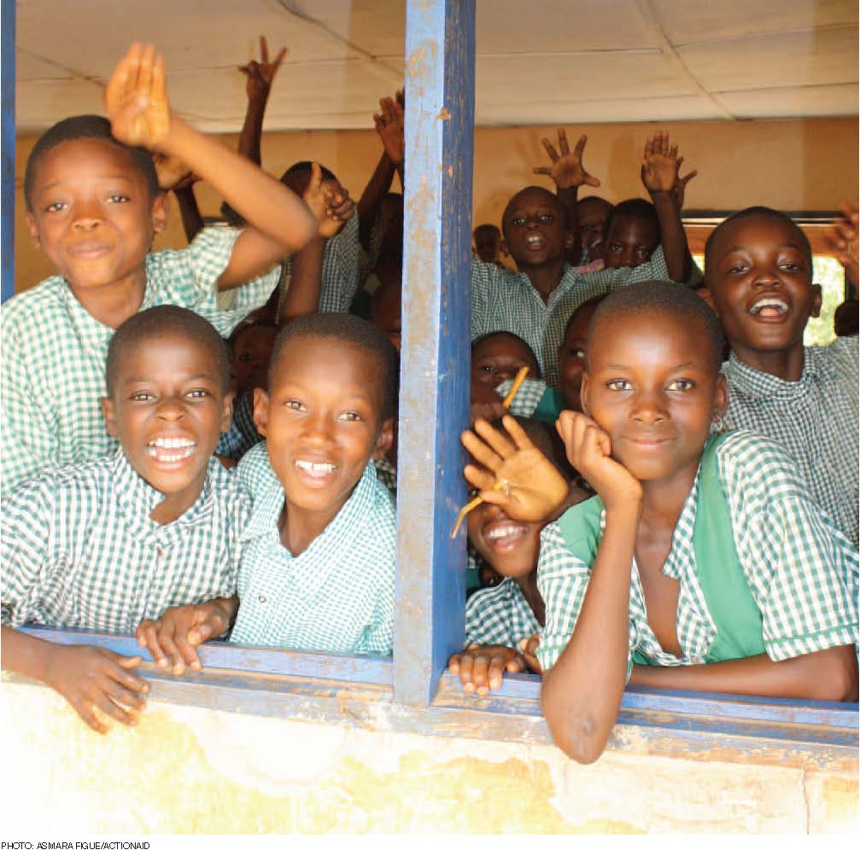
often resulting in girls being forced to marry against their will, or payment of fines in the cases of pregnancy. If outside intervention is sought it is most likely to be through informal traditional systems with similar results. community justice systems do not always appear to work in the best interests of the girls, and only a tiny minority of cases are reported to Smcs, dEos or police, or lead to counselling, care or health advice. Formal structures suffer from lack of resources, training and insufficient referral and follow-up systems. communication and collaboration between community and official welfare and justice systems is poor, and there is a clear need for building more robust response systems.
Conclusions
the report paints at best an uneven picture, and frequently a bleak picture of violence and inequalities in girls’ lives and communities. the conclusion summarises cross-cutting issues across the three project sites, and discusses the implications of variations in the findings between the sites in relation to mismatches between discourse and practice, the effects of modernity on gender and violence, and the building of effective partnerships. the report concludes with recommendations for international, national and district level advocacy, local school and community interventions and future research.

